UNIT 1
LESSON 6 – THE BROWNS

- 1 Read the text.
Pročitaj tekst.
JOSEPH
PENELOPE
NOAH
ANNE

This is the Brown family.
Ovo je obitelj Brown.

They are Anne, Joseph, Penelope and Noah.
Oni su Anne, Joseph, Penelope i Noah.

I am Penelope.
Ja sam Penelope.

I have got blond hair. I have got green eyes.
Imam plavu kosu. Imam zelene oči.

I like swimming.
Volim plivanje.


13

I am Noah. I am 13 years old. I have got short brown hair.
Ja sam Noah. Imam 13 godina. Imam kratku smeđu kosu.

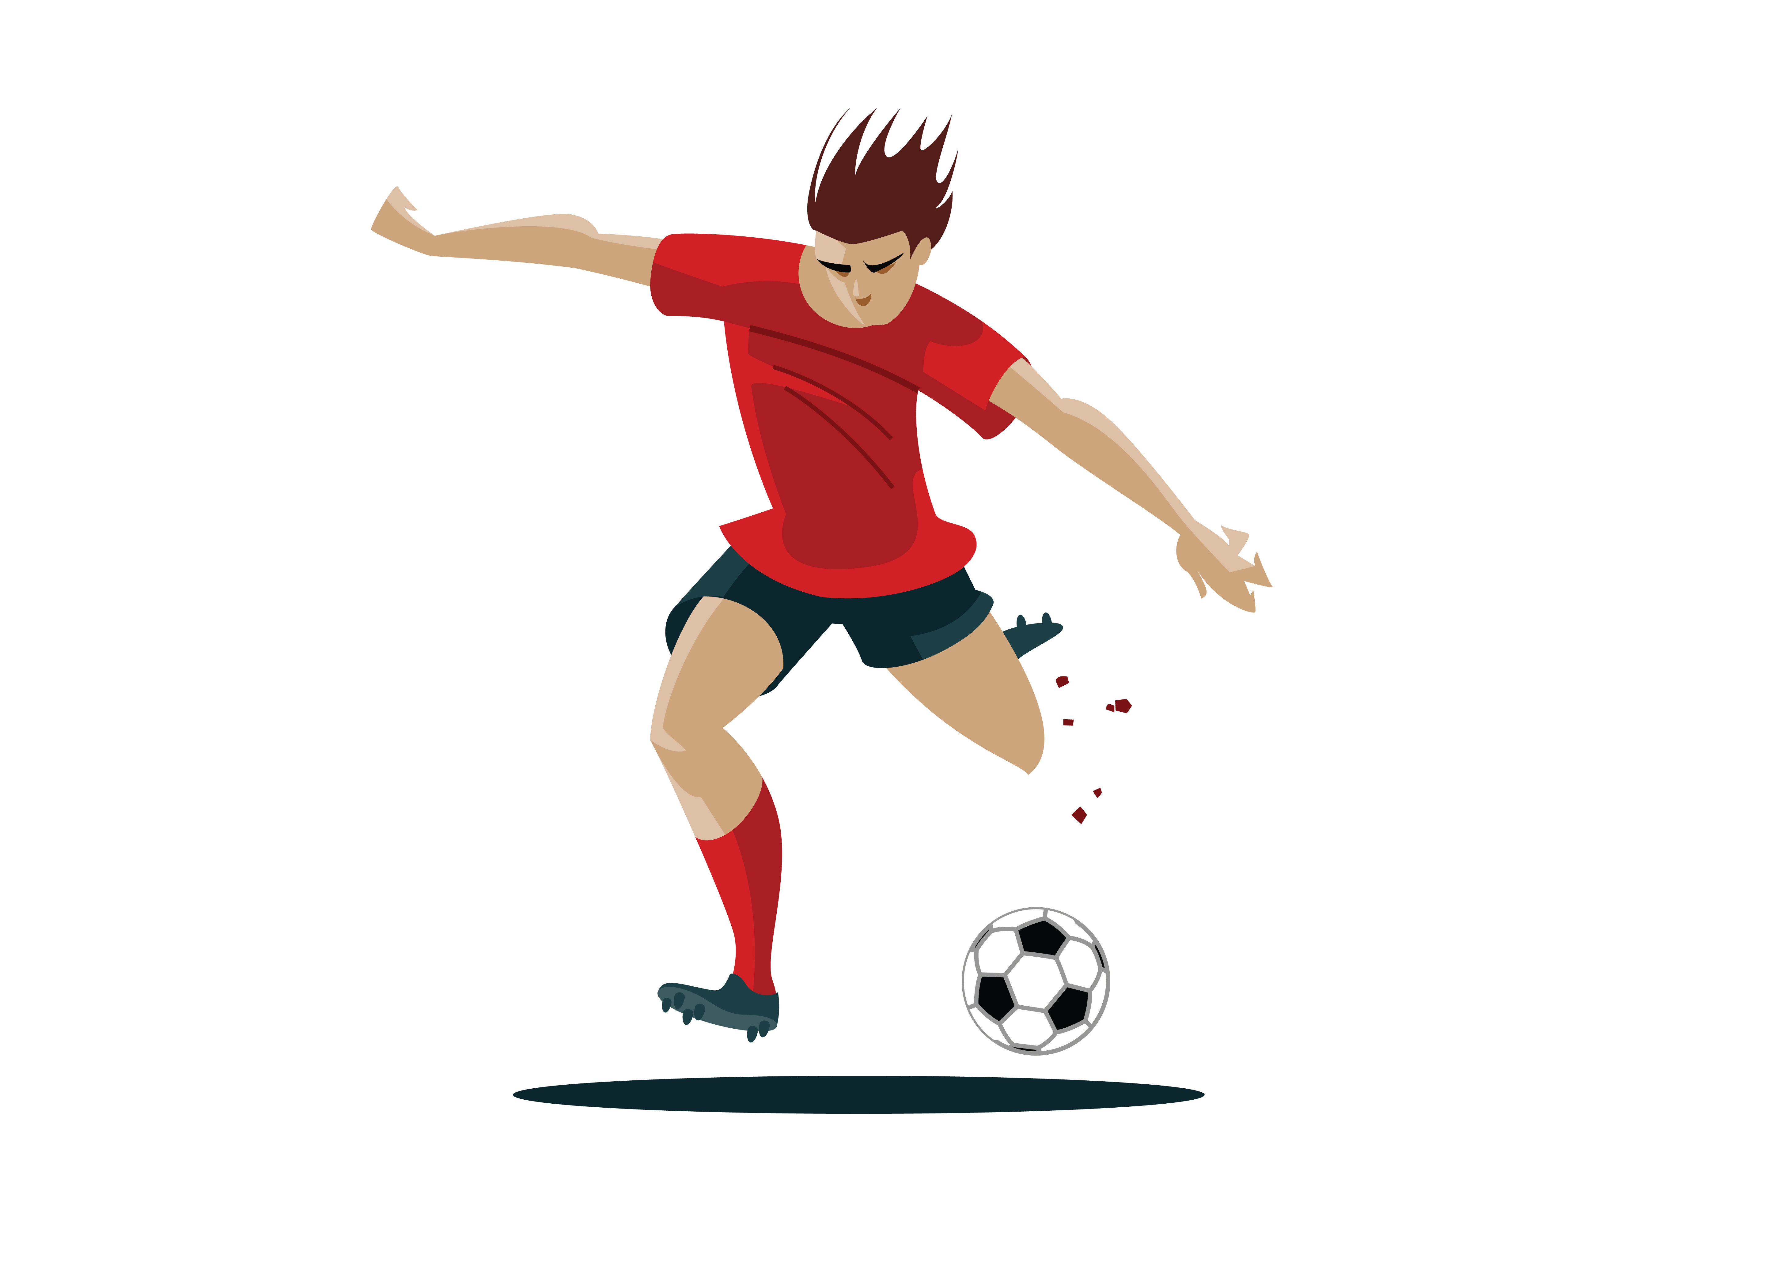

I have got brown eyes. I like football.
Imam smeđe oči. Volim nogomet.



I am Joseph.
Ja sam Josephh.
40

I am 40 years old.
Imam 40 godina.

I am a game developer.
Ja sam programer video igrica.


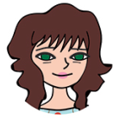

I am Anne.

Ja sam Anne.

I am a doctor.
Ja sam liječnica.

I like reading books.
Volim čitati knjige.


- 2
a) Read the sentences in Croatian.
Pročitaj rečenice na hrvatskom.

Complete the sentence in English.
Dopuni rečenice na engleskom.

b) Choose the words from the table to describe the Browns.
Izaberi riječ iz tablice kako bi opisao članove obitelji Brown.

happy | sretan
kind | ljubazan
friendly | druželjubiv
helpful | spreman pomoći
boring | dosadan
shy | sramežljiv

Anne je ljubazna.
Anne is ______kind______________ .

Noah je spreman pomoći.
Noah is ________________________ .

Penelope je druželjubiva.
Penelope is _________________________ .

Noah je sramežljiv.
Noah is ___________________________ .

Joseph nije dosadan.
Joseph isn't _______________________ .

- 3
a) Who are the members of Brown family?
Tko su članovi obitelji Brown?
b) Write their names on the lines.
Napiši njihova imena na prazne crte.
c) Write a few words that describe them in the frames.
Napiši nekoliko riječi koje ih opisuju u okvire.

- 4 What would you like to do when you grow up?
Što bi volio raditi kada odrasteš?
Anne is a doctor.
Anne je liječnica.

Joseph is a game developer.
Joseph je programer video igrica.

a) Draw or find the picture of your favourite job.
Nacrtaj ili zalijepi sliku svojeg omiljenog zanimanja.

